MVP env prepare and code update for Jenkins

1. Configure remote access via SSH for root account with standard password for servers in VBE IT lab. (use tester/tester to access)
2. Install TeMIP 6.2 on osst004 as per the instruction 

<https://ent312.sharepoint.hpe.com/teams/OVTeMIP/TeMIPOpenMediation/_layouts/15/WopiFrame.aspx?sourcedoc=/teams/OVTeMIP/TeMIPOpenMediation/Shared%20Documents/Preparing%20a%20machine%20for%20TeMIP%20CA%20builds%20and%20tests.docx&action=default&DefaultItemOpen=1>

* 1. Ignore a step on upgrading openldap package
  2. Ignore manipulation on liblber
  3. /etc/hosts file should look like on patativ3
  4. Ignore chapter 7
  5. Ignore chapter 11 except section 11.1

1. Install standard TeMIP 6.2 patches by the script mentioned in the instruction
2. Install Oracle JDK 1.7 latest update (80) from RPM  downloaded from Oracle site or taken from <https://csvnaus1-pro.austin.hpecorp.net:18580/svn/temip-openmediation/jenkins/mst/userContent/jdk/linux/jdk-7u80-linux-x64.rpm>
3. Add a new node to Jenkins by copying from patativ3.
4. Configure newly added node
   1. Labels: linux mvp temip temip6.2 rhel6 slave
   2. Other parameters as by example from patativ3

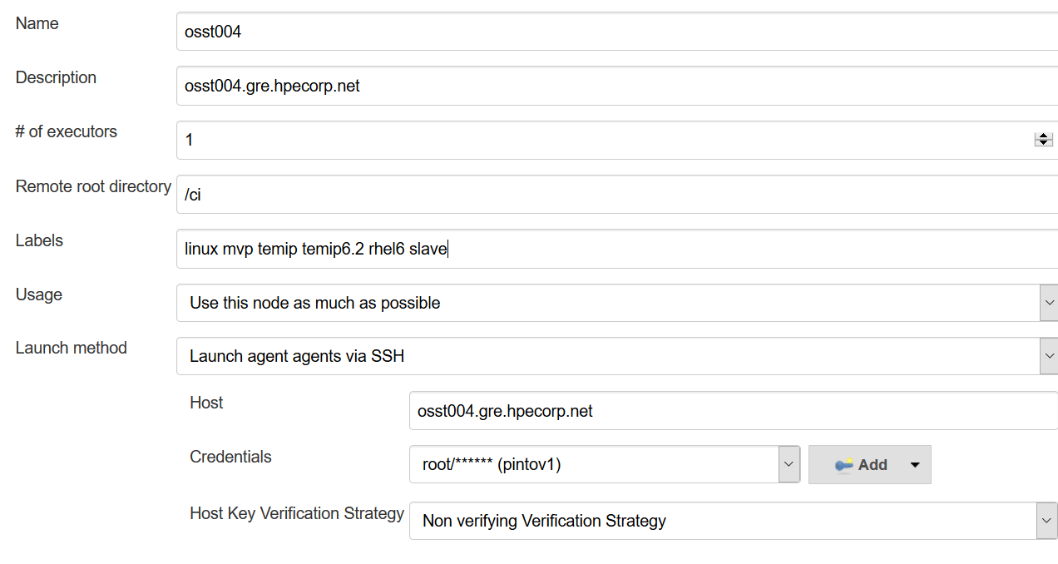

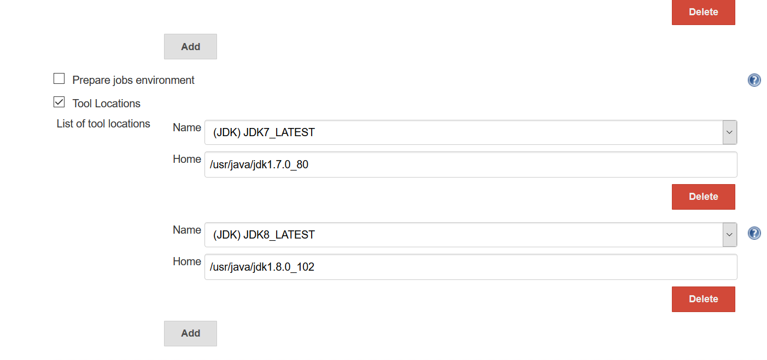

1. Configure infrastructure_daily_config_restart Jenkins job to run on a node for building MVPs: Maven, sudoers, subversion (configs + install), mtu.
2. Save Jenkins configs to Git
3. Actualize information for osst004 on the servers table: <https://hpe.sharepoint.com/teams/CMSOSSRussia/Lists/Servers/All.aspx>

TODO-> Nothing, TeMIP version -> 62, TeMIP level 01, TeMIP revision -> B, Role -> CI slave

1. MVP code update sample :

Netcool_FMI_CIC:

<https://csvnaus1-pro.austin.hpecorp.net:18580/svn/temip-openmediation-mvp/Netcool_FMI_CIC/branches/Level2-T2.3VFT2T/>

The output of command “svn diff -r 8102:8182”:

Index: netcool-fmi-cic-mvp/tests/netcool-fmi-cic-mvp-integration-tests/pom.xml

===================================================================

--- netcool-fmi-cic-mvp/tests/netcool-fmi-cic-mvp-integration-tests/pom.xml     (revision 8102)

+++ netcool-fmi-cic-mvp/tests/netcool-fmi-cic-mvp-integration-tests/pom.xml     (revision 8182)

@@ -71,7 +71,7 @@

                                                                <artifactItem>

                                                                        <groupId>com.hp.openmediation</groupId>

                                                                        <artifactId>build-tools</artifactId>

-                                                                       <version>1.0-nom-4</version>

+                                                                       <version>1.0-nom-6</version>

                                                                        <type>pl</type>

                                                                        <classifier>formatshell</classifier>

                                                                        <destFileName>formatshell.pl</destFileName>

Index: netcool-fmi-cic-mvp/tests/netcool-fmi-cic-mvp-integration-tests/src/get_resources.sh

===================================================================

--- netcool-fmi-cic-mvp/tests/netcool-fmi-cic-mvp-integration-tests/src/get_resources.sh        (revision 8102)

+++ netcool-fmi-cic-mvp/tests/netcool-fmi-cic-mvp-integration-tests/src/get_resources.sh        (revision 8182)

@@ -10,5 +10,5 @@

mkdir -p resources

cd resources

pwd

-wget -nv -c -N "<http://vbet0007g.gre.hpecorp.net:18080/view/NOM/job/NOM_build/301/jdk=7_h06_o21,os=linux,osver=n720kit/artifact/openmediation/tests/target/dist_nom_kits/openmediation-7.2.0-L.tar>"

-wget -nv -c -N "<http://vbet0007g.gre.hpecorp.net:18080/view/NOM/job/TEMIP_CA_build/819/jdk=7_h06_o21,os=linux,osver=t220kit/artifact/temip-ca/tests/target/dist_product_kits/temip-ca-2.3VFT2T.0-L.tar>"

+wget -nv -c -N "<http://vbet0007g.gre.hpecorp.net:8081/repository/maven-releases/com/hp/openmediation/openmediation/7.2.0/openmediation-7.2.0-L.tar>"

+wget -nv -c -N "<http://vbet0007g.gre.hpecorp.net:8081/repository/maven-releases/com/hp/openmediation/temip-ca/2.3VFT2T.0/temip-ca-2.3VFT2T.0-L.tar>"

Index: check_env.sh

===================================================================

--- check_env.sh        (revision 8102)

+++ check_env.sh        (revision 8182)

@@ -738,9 +738,9 @@

        true

}

function check_t_220_kit_os_L_ANY {

-       assert_java_version "7_21" && \

-       assert_os_version "5_8" && \

-       assert_temip_version "6_1" && \

+       assert_java_version "7_21|7_80" && \

+       assert_os_version "5_8|6_6" && \

+       assert_temip_version "6_1|6_2" && \

        true

}

function check_t_220_test_os_L_ANY {

@@ -880,8 +880,12 @@

        perl -W -pe "s|^(TFR\.)?TFRTAO2XV.*\n||g" | \

        perl -W -pe "s|^(TFR\.)?TFRTFCV.*\n||g" | \

        perl -W -pe "s/^(TFR\.)?TFRTNS(CLR|SRV)V.*\n//g" | \

-       perl -W -pe "s/^(TWS\.)?TWS(DICTAM|MISCSVCSAM|EXAMPLE)V.*\n//g" | \

+       perl -W -pe "s/^(TWS\.)?TWS(WEBSRVC|DICTAM|MISCSVCSAM|EXAMPLE)V.*\n//g" | \

        perl -W -pe "s|^(TFR\.)?TFRITORT6XV.*\n||g" | \

+       perl -W -pe "s|^(TFR\.)?TFRBASEV.*\n||g" | \

+       perl -W -pe "s|^(ACK\.)?ACKBASEV.*\n||g" | \

+       perl -W -pe "s|^(RFM\.)?RFMBINV.*\n||g" | \

+       perl -W -pe "s|^(TEMIP\.)?TEMIP.*\n||g" | \

        if grep -E '[[:alnum:]]'

        then

                return 1

Index: Jenkinsfile

===================================================================

--- Jenkinsfile (revision 8102)

+++ Jenkinsfile (revision 8182)

@@ -5,7 +5,7 @@

def buildFailureEmail = 'cms-oss-russia-adapters@hpe.com'

stage("Build MVP") {

-    node("t220kit&&linux") {

+    node("mvp&&linux") {

         stage("Collect sources") {

             checkout(

                     changelog: false,

@@ -26,7 +26,7 @@

             )

         }

         try {

-            withEnv(["JAVA_HOME=${tool name: '7_h06_o21', type: 'jdk'}"]) {

+            withEnv(["JAVA_HOME=${tool name: 'JDK7_LATEST', type: 'jdk'}"]) {

                 stage("Build with the build script") {

                     sh "./build.sh"

                 }

@@ -39,7 +39,7 @@

                         onlyIfSuccessful: false

                 )

             }

-            withEnv(["JAVA_HOME=${tool name: '7_h06_o21', type: 'jdk'}"]) {

+            withEnv(["JAVA_HOME=${tool name: 'JDK7_LATEST', type: 'jdk'}"]) {

                 stage("Run tests") {

                     sh """

echo "JAVA_HOME is $JAVA_HOME"

@@ -68,13 +68,7 @@

             throw all

         } finally {

             stage("Build result audit") {

-                checkstyle pattern: '**/target/reports/checkstyle/*.xml', shouldDetectModules: true, useStableBuildAsReference: true

-                findbugs pattern: '**/target/reports/findbugs/*.xml', shouldDetectModules: true, useStableBuildAsReference: true

-                pmd pattern: '**/target/reports/pmd/*.xml', shouldDetectModules: true, useStableBuildAsReference: true

-                openTasks excludePattern: '**/target/**/*, ci_build_resources/', high: 'FIXME', ignoreCase: true, low: 'XXX', normal: 'TODO', pattern: '**', shouldDetectModules: true, useStableBuildAsReference: true

                 junit allowEmptyResults: true, keepLongStdio: true, testResults: '**/target/surefire-reports/TEST-*.xml'

-                warnings consoleParsers: [[parserName: 'Java Compiler (javac)'], [parserName: 'GNU Make + GNU C Compiler (gcc)'], [parserName: 'Maven']], shouldDetectModules: true, useStableBuildAsReference: true

-                step([$class: 'AnalysisPublisher', useStableBuildAsReference: true])

             }

         }

     }

Index: get_build_resources.sh

===================================================================

--- get_build_resources.sh      (revision 8102)

+++ get_build_resources.sh      (revision 8182)

@@ -4,5 +4,5 @@

mkdir -p ci_build_resources

wget -c -N --no-proxy -nd -P ci_build_resources \

-http://vbet0007g.gre.hpecorp.net:18080/view/NOM/job/NOM_build/301/jdk=7_h06_o21,os=linux,osver=n720kit/artifact/openmediation/tests/target/dist_nom/openmediation-7.2.0.zip \

-http://vbet0007g.gre.hpecorp.net:18080/view/NOM/job/TEMIP_CA_build/852/jdk=7_h06_o21,os=linux,osver=t220kit/artifact/temip-ca/tests/target/dist_product/temip-ca-2.3VFT2T.0-L.zip

+http://vbet0007g.gre.hpecorp.net:8081/repository/maven-releases/com/hp/openmediation/openmediation/7.2.0/openmediation-7.2.0.zip \

+http://vbet0007g.gre.hpecorp.net:8081/repository/maven-releases/com/hp/openmediation/temip-ca/2.3VFT2T.0/temip-ca-2.3VFT2T.0.zip

If one MVP does not have Jenkins integration, need to add Jenkins integration files (must be copied with svn cp command!) (Jenkins file and etc, by example from other MVP which has JenkinsCi integration)

1. Unsure that pills are blue on Jenkins by fixing here and there things what fail.

